Carlos Jimenez, Wan Koo, Jose A. Nieto

* 1. Databse: janieto2, Table: TableTest
  2. Scope

The database is used for the Global Programs Office. What this database encompasses are the student’s application regarding various study abroad programs. The users will be able to create a log in that uses their unique email address and they will also create a password. The database will store various information which includes the student pictures (after their trip), Linkedin link, video link, ID, student picture, an essay, contact information, GPA, classification, and whether they have been abroad or not. The database will be separated into three different users (students, instructors, and admin). The key entities of this database will include the student and student information, the student’s application and application status, and the staff. The system will also be able to send notifications to the staff, students, and faculty depending on the various information like the status of the application. The system will also be able to generate a report that is sent to the staff and faculty based on the statistics of the students and their determining ranking.

1.3 Requirements:

1. The system will provide program description, location, datelines, requirements, eligibility, pictures, funding (if applicable), costs.
2. The system will provide a contact us section in with links where the student is able to get more information.
3. The system will have an application submitter where they student is able to register their contact info (first, last, middle name, ID), demographic, student Linkedin link, upload option for student essay, and upload option for student video link.
4. The system will be able to notify students and faculty.
5. The system will give updates on the application status (accepted, rejected, or waiting). This information will be accessible when the student logins to the website.
6. The system will notify staff of submission.
7. The system will give information about scholarship awards.
8. The system will be able to send a notification regarding the reminder about the deadline for students through text or email.
9. The system will be able to generate reports to the admins regarding number of applicants, demographic of applicants, applicants experience pre and post program evaluations.
10. The system will be able to give a report to the admins regarding the best applications by GPA, classification and whether they have been abroad or not.
11. The accepted applicants should be able to upload 10 pictures and an essay about their experience.
12. The system will have an upload option to send flight itinerary and agenda for the week.
13. The system will have an upload option for students to complete their emergency form and international SOS forms.
14. The system will have an upload options where students can post receipt of their program payments.
15. The system will provide easy access portal to change program info or new deadlines.
    1. Entity-Relationship Model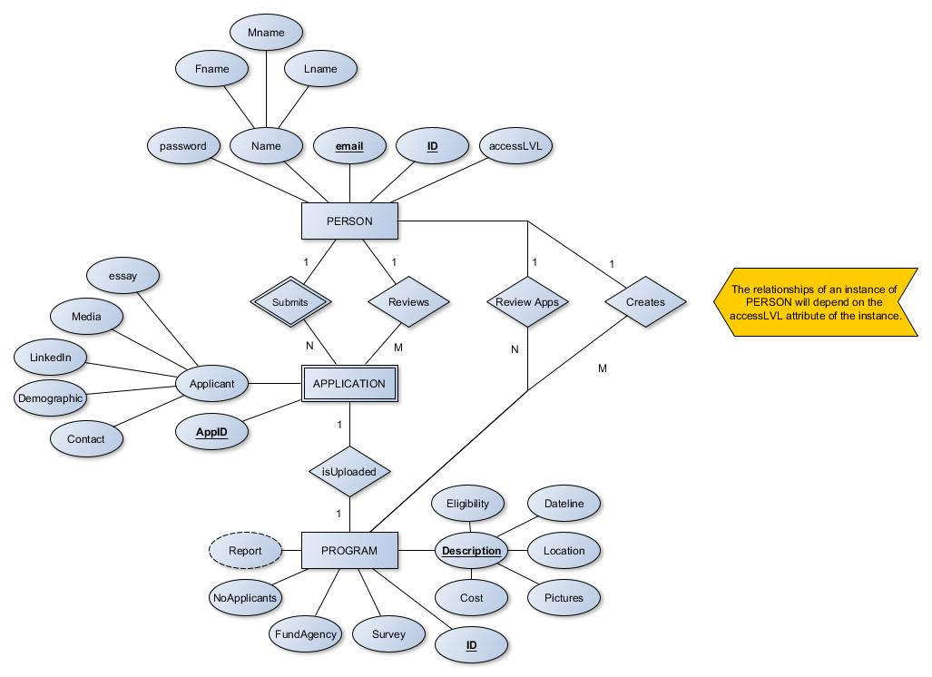
    2. Relational Model

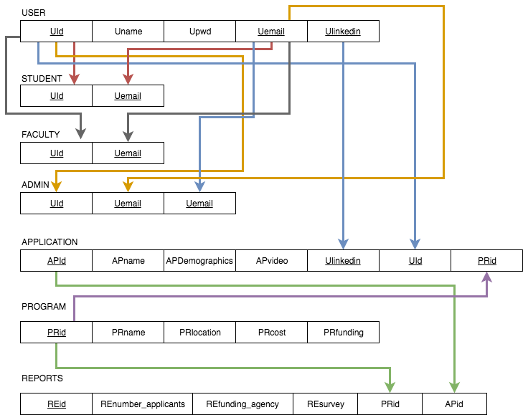

* 1. References
* Elmasri, R., & Navathe, S. B. (n.d.). Fundamentals of Database Systems (7th ed.).
* MySQL 8.0 Reference Manual :: 3.3 Creating and Using a Database. (n.d.). Retrieved from https://dev.mysql.com/doc/refman/8.0/en/database-use.html